

|  |
| --- |
| Ai~~r~~Ms Services  User Manual |
| * *A Complete Solution to Aircraft Predictive Maintenance* |
| December 14  AirMs  Authored by: Manthan Dhisale  Aditya Iyenger |

Ai~~r~~Ms

*Index*

1. Graphic User Interface…………………………………………..…………..3
2. Interface Breakdown…………………………………………………………4
3. Data Wrangling GUI………………………………………………..…………5
4. Exploratory Analysis GUI………………………………………….……….7
5. TTF (Time To Failure Prediction)…………………………..……………9
6. Binary Classification for predicting failure……………………..…10
7. Multi-class Classification for predicting the failure class…..11
8. Our Unique Selling Propositions……………………………………….12

Graphic User Interface

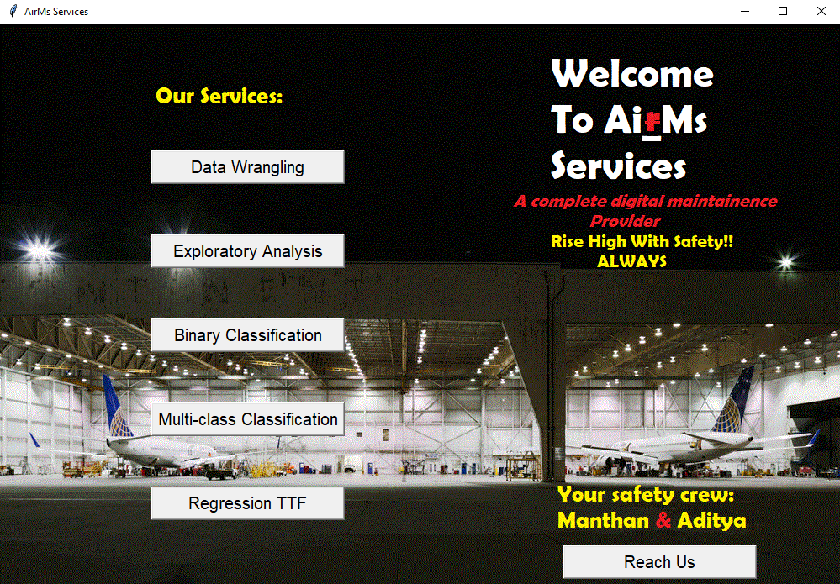

A complete user-easy and interactive interface, through which a User can access to 5 Google Colab Notebooks online.

Also Users can reach the Safety Crew (AirMs Leaders) through Reach Us features, where they can drop a mail or view the leaders profile.

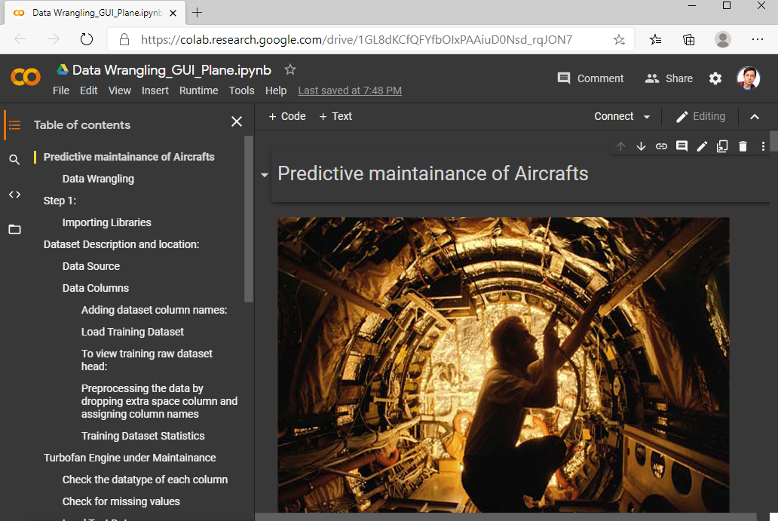 

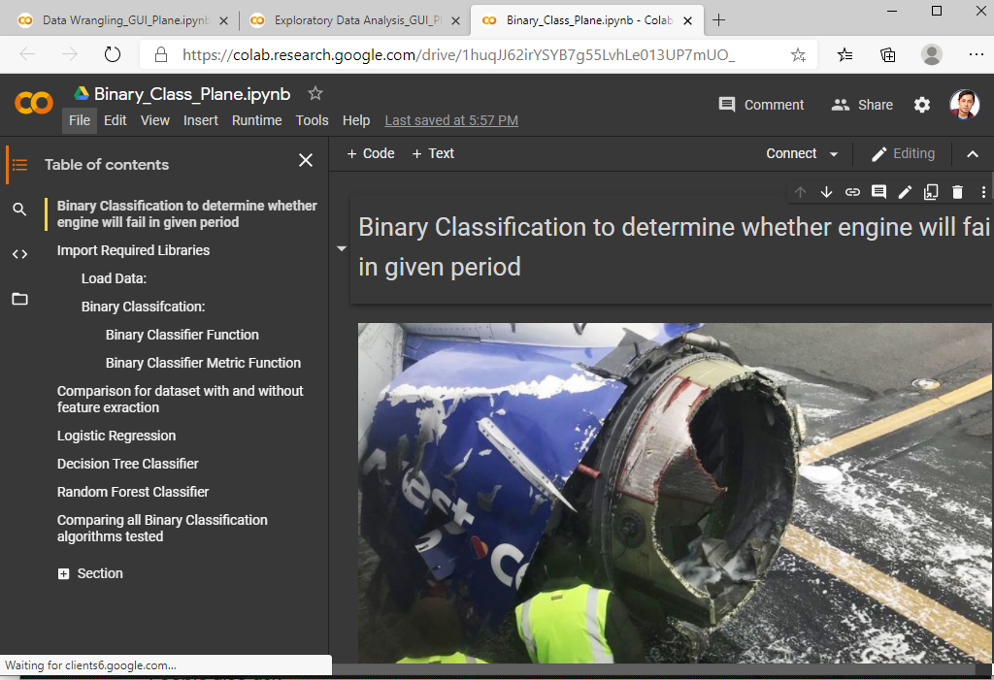

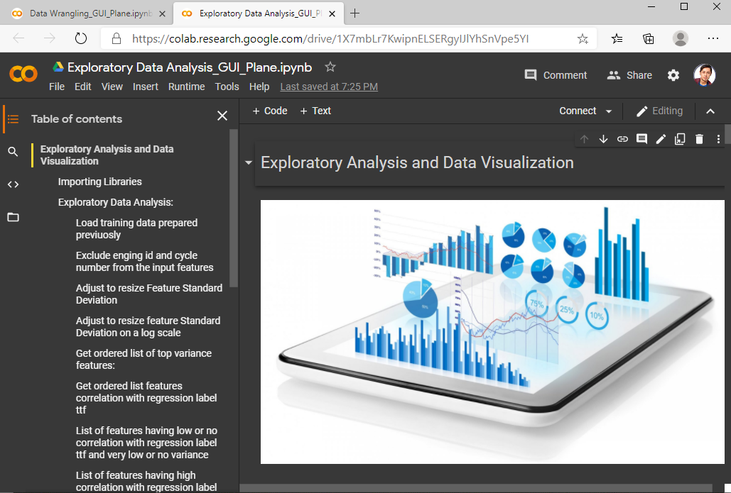

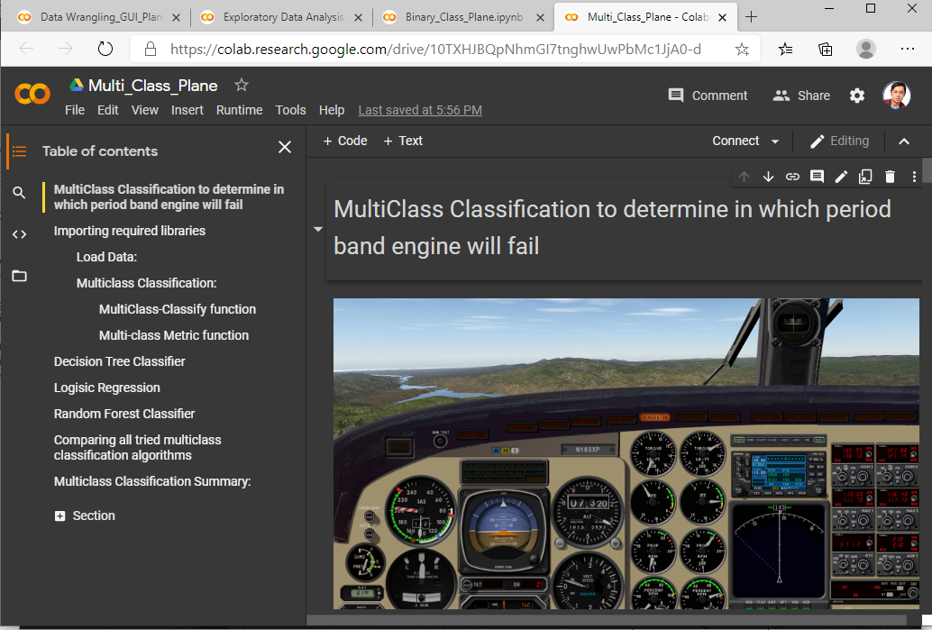



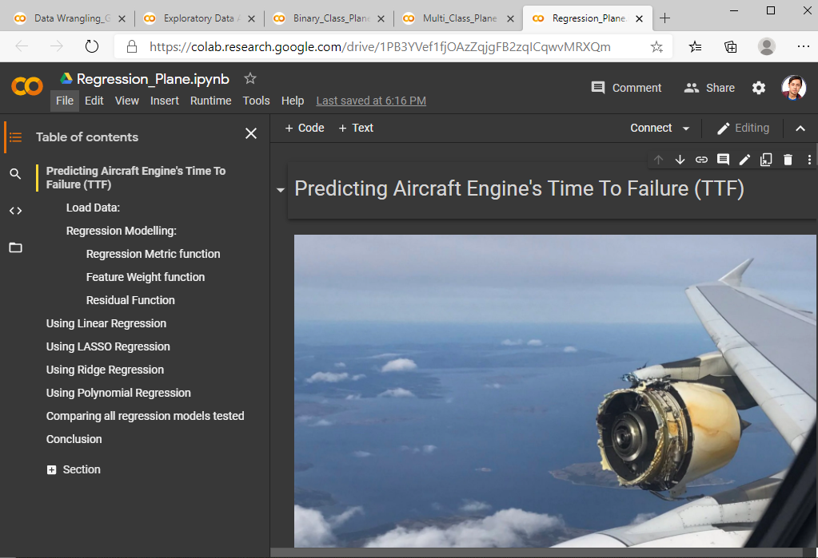

Data Wrangling ( A Code free Interface with Colab Form Features for GUI)

1. Colab Buttons for Loading data and training:

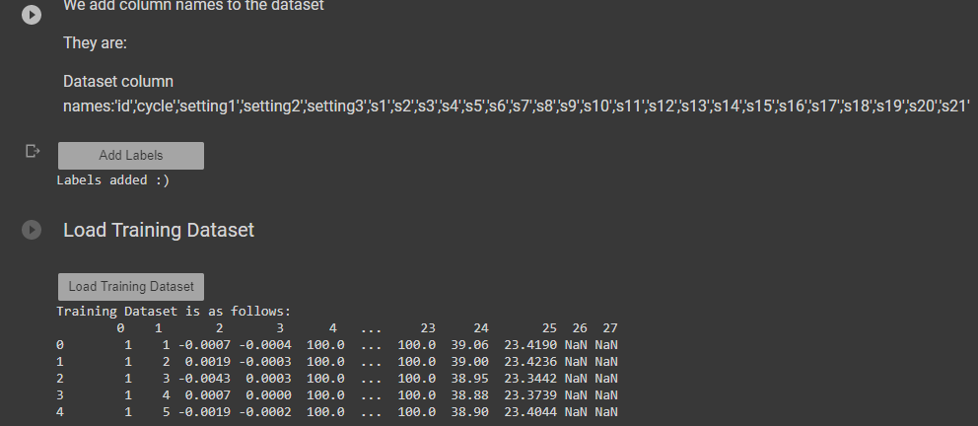

1. Stat Button:

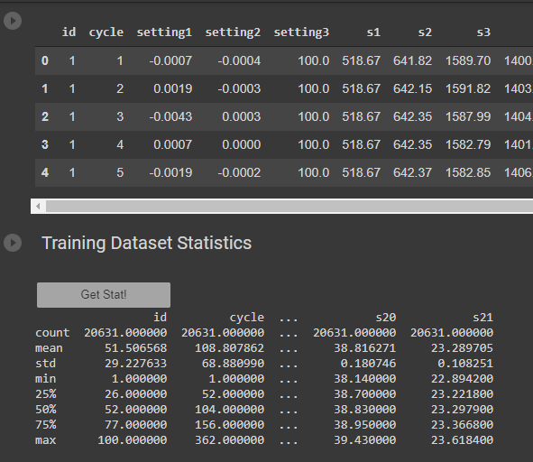

1. Checkbox decisions:

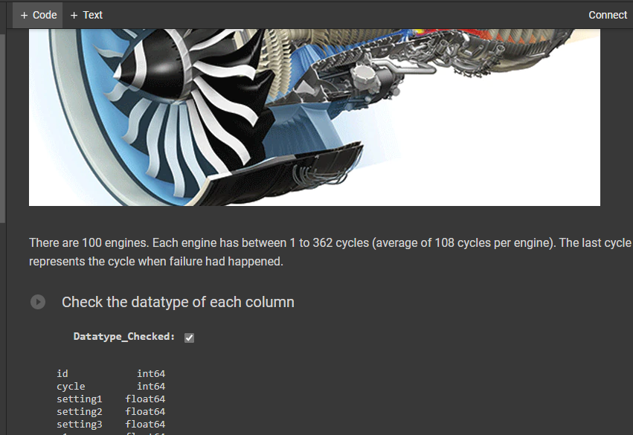

1. Scroll feature to define no. of cycles and no. of features:

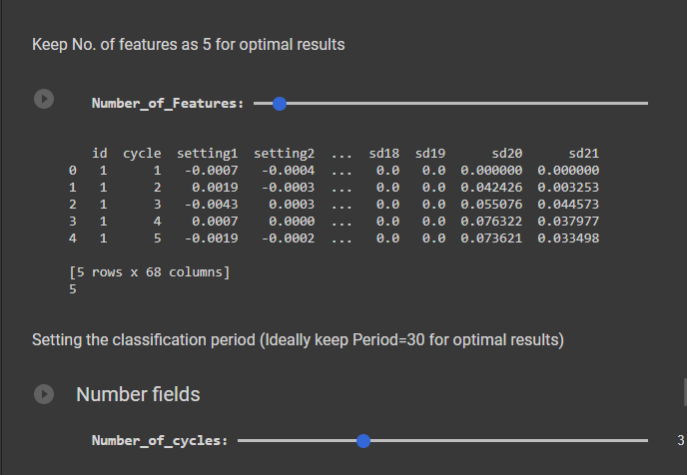

Exploratory Analysis and Data Visualizations

1. Scroll based Hyper-parameter Selection and plot size:

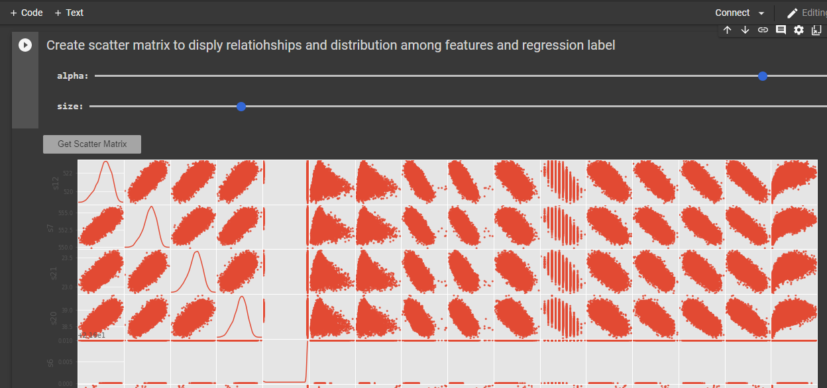

1. Selecting Sensor and getting the data trends

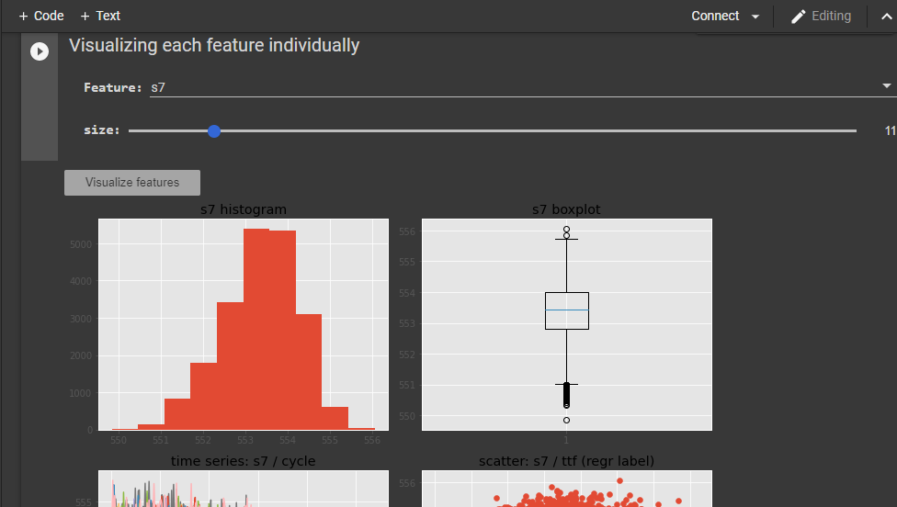

1. Time Plots button access

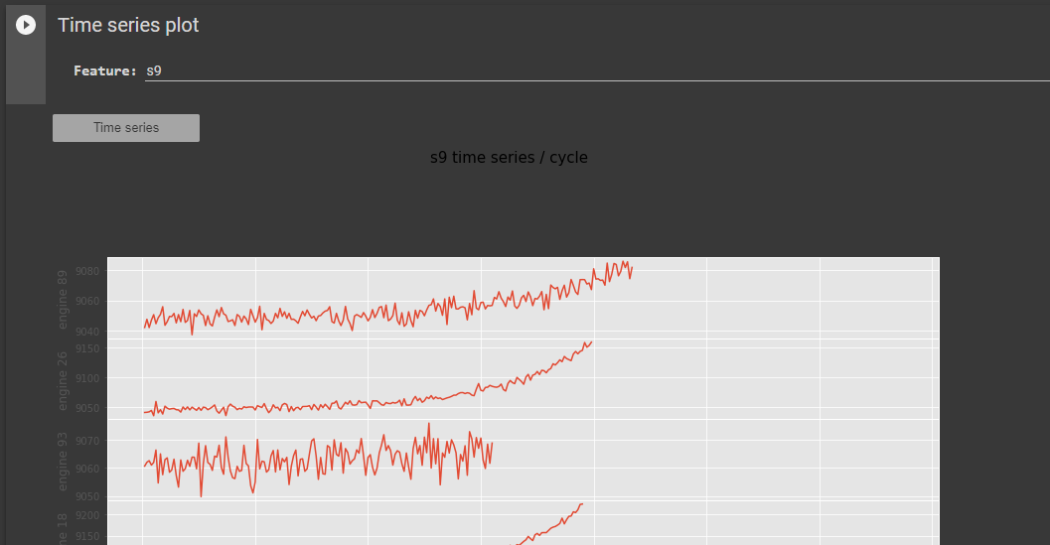

|  |
| --- |
| Time To Failure Prediction using Regression model   1. Visualization comparison of Train/Test      1. Performance comparison using various models     Failure Prediction using Binary Classifier   1. Visualization Plots of Precision and Recall      1. Performance Comparison of various models     Failure Prediction using Multi-class Classifier   1. Visualization Plots of Precision and Recall      1. Performance Comparison of various models     **Our Unique Selling Propositions** |
| ***RISE HIGH WITH SAFETY***  ***ALWAYS!!*** |
|  |